Practical-1
Aim :- Study of basic architecture of 8085 microprocessor.
Theory :-
- 8085 is pronounced as "eighty-eighty-five" microprocessor. It is an 8-bit microprocessor designed by Intel in 1977 using NMOS (negative-channel metal-oxide semiconductor) technology.

- It has the following configuration –
  - 8-bit data bus
  - 16-bit address bus, which can address up to 64KB
  - A 16-bit program counter
  - A 16-bit stack pointer
  - Six 8-bit registers arranged in pairs: BC, DE, HL
  - Requires +5V supply to operate at 3.2 MHZ single phase clock
It is used in washing machines, microwave ovens, mobile phones, etc.

Figure: Architecture of 8085 Microprocessor
8085 consists of the following functional units –
Accumulator

- It is an 8-bit register used to perform arithmetic, logical, I/O & LOAD/STORE operations. It is connected to internal data bus & ALU.
Arithmetic and logic unit

- As the name suggests, it performs arithmetic and logical operations like Addition, Subtraction, AND, OR, etc. on 8-bit data.
General purpose register

- There are 6 general purpose registers in 8085 processor, i.e. B, C, D, E, H & L. Each register can hold 8-bit data.
- These registers can work in pair to hold 16-bit data and their pairing combination is like B-C, D-E & H-L.
Program counter

- It is a 16-bit register used to store the memory address location of the next instruction to be executed. Microprocessor increments the program counter whenever an instruction is being executed, so that the program counter points to the memory address of the next instruction that is going to be executed.
Stack pointer

- It is also a 16-bit register works like stack, which is always incremented/decremented by 2 during push & pop operations.
Temporary register

- It is an 8-bit register, which holds the temporary data of arithmetic and logical operations.
Flag register

- It is an 8-bit register having five 1-bit flip-flops, which holds either 0 or 1 depending upon the result stored in the accumulator.

- These are the set of 5 flip-flops −
● Sign (S)
● Zero (Z)
● Auxiliary Carry (AC)
● Parity (P)
● Carry (C)

- Its bit position is shown in the following table –

D7 | D6 | D5 | D4 | D3 | D2 | D1 | D0
S | Z |  | AC |  | P |  | CY

- Sign (S) - If D7 of the result is 1 then sign flag is set, otherwise reset. As we know that a number on the D7 always decides the sign of the number.
if D7 is 1: the number is negative.
if D7 is 0: the number is positive.

- Zero (Z) :- If the result stored in an accumulator is zero then this flip flop is set otherwise it is reset.

- Auxiliary Carry (AC) :- If any carry goes from D3 to D4 in the output then it is set
otherwise it is reset.

- Parity (P) :- If the no of 1's is even in the output stored in the accumulator then it is set otherwise it is reset for the odd.

- Carry (C) :- If the result stored in an accumulator generates a carry in its final output then it is set otherwise it is reset.
Instruction register and decoder

- It is an 8-bit register. When an instruction is fetched from memory then it is stored in the Instruction register. Instruction decoder decodes the information present in the Instruction register.

Timing and control unit

- It provides timing and control signals to the microprocessor to perform the various operation. It has three control signals. It controls all external and internal circuits. It operates with reference to clock signal. It synchronizes all the data transfers. There are three control signals:

- ALE - Arithmetic Latch Enable, It provides a control signal to synchronize the components of a microprocessor.
- RD - This is active low used for reading operation.
- WR - This is an active low used for writing operations.

- There are three status signals used in microprocessor S0, S1 and IO/M. It changes its status according to the provided input to these pins.

IO/M(Active Low) | S1 | S2 | Data Bus Status(Output)
0 | 0 | 0 | Halt
0 | 0 | 1 | Memory WRITE
0 | 1 | 0 | Memory READ
1 | 0 | 1 | IO WRITE
1 | 1 | 0 | IO READ
0 | 1 | 1 | Opcode fetch
1 | 1 | 1 | Interrupt acknowledge

Interrupt control

- As the name suggests it controls the interrupts during a process. When a microprocessor is executing a main program and whenever an interrupt occurs, the microprocessor shifts the control from the main program to process the incoming request. After the request is completed, the control goes back to the main program.

- There are 5 interrupt signals in 8085 microprocessor: INTR, RST 7.5, RST 6.5, RST 5.5, TRAP.
Serial Input/output control

- It controls the serial data communication by using these two instructions: SID (Serial input data) and SOD (Serial output data).

Address buffer and address-data buffer

- The content stored in the stack pointer and program counter is loaded into the address buffer and address-data buffer to communicate with the CPU. The memory and I/O chips are connected to these buses; the CPU can exchange the desired data with the memory and I/O chips.
Address bus and data bus

- Data bus carries the data to be stored. It is bidirectional, whereas address bus carries the location to where it should be stored, and it is unidirectional. It is used to transfer the data & Address I/O devices.

Practical-2
Aim :- Instruction Set of 8085 Microprocessor.
Theory :-

An instruction is a binary pattern designed inside a microprocessor to perform a specific function.

    - The entire group of instructions that a microprocessor support is called Instruction Set.
    - 8085 has 246 instructions.
    - Each instruction is represented by an 8-bit binary value.
    - These 8-bits of binary value is called Op-Code or Instruction Byte.
Classification of Instruction Set :-
- Data Transfer Instructions
- Arithmetic Instructions
- Logical Instructions
- Branching Instructions
- Control Instructions

Data Transfer Instructions :-

  - These instructions move data between registers, or between memory and registers.
  - These instructions copy data from source to destination.
  - While copying, the contents of source are not modified.
MOV
Opcode | Operand | Description
MOV | Rd, Rs  Rd, M  M, Rs | Copy from source to destination.

- This instruction copies the contents of the source register into the destination register.
- The contents of the source register are not altered.
- If one of the operands is a memory location, its location is specified by the contents of the HL registers.
- Example:
  - MOV B, C
  - MOV B, M
  - MOV N, C

MVI
Opcode | Operand | Description
MVI | Rd, Data  M, Data | Move immediate 8-bit.

- The 8-bit data is stored in the destination register or memory.
- If the operand is a memory location, its location is specified by the contents of the HL registers.
- Example:
  - MVI A, 57H
  - MVI M, 57H

LXI
Opcode | Operand | Description
LXI | Reg-pair, 16-bit data | Load register pair immediate

- This instruction loads 16-bit data in the register pair.
- Example: LXI H, 2034 H

LDA
Opcode | Operand | Description
LDA | 16-bit address | Load Accumulator

- The contents of a memory location, specified by a 16-bit address in the operand, are copied to the accumulator.
- The contents of the source are not altered.
- Example: LDA 2034H

LDAX
Opcode | Operand | Description
LDAX | B/D Register Pair | Store accumulator direct

- The contents of the designated register pair point to a memory location.
- This instruction copies the contents of that memory location into the accumulator.
- The contents of either the register pair or the memory location are not altered.
- Example: LDAX B

LHLD
Opcode | Operand | Description
LHLD | 16-bit address | Load H-L registers direct

- This instruction copies the contents of memory location pointed out by 16-bit address into register L.
- It copies the contents of next memory location into register H.
- Example: LHLD 2040 H

STA
Opcode | Operand | Description
STA | 16-bit address | Store accumulator direct

- The contents of accumulator are copied into the memory location specified by the operand.
- Example: STA 2500 H

STAX
Opcode | Operand | Description
STAX | Register Pair | Store accumulator indirect

- The contents of accumulator are copied into the memory location specified by the contents of the register pair.
- Example: STAX B

SHLD
Opcode | Operand | Description
SHLD | 16-bit address | Store H-L registers direct

- The contents of register L are stored into memory location specified by the 16-bit address.
- The contents of register H are stored into the next memory location.
- Example: SHLD 2550 H

XCHG
Opcode | Operand | Description
XCHG | None | Exchange H-L with D-E

- The contents of register H are exchanged with the contents of register D.
- The contents of register L are exchanged with the contents of register E.
- Example: XCHG

Arithmetic Instructions :-

- These instructions perform the operations like:

  - Addition
  - Subtraction
  - Increment
  - Decrement
ADD
Opcode | Operand | Description
ADD | R  M | Add register or memory to accumulator
- The contents of register or memory are added to the contents of accumulator.
- The result is stored in accumulator.
- If the operand is memory location, its address is specified by H-L pair.
- All flags are modified to reflect the result of the addition.
- Example: ADD B or ADD M

ADC

Opcode | Operand | Description
ADC | R  M | Add register or memory to accumulator with carry

    - The contents of register or memory and Carry Flag (CY) are added to the contents of accumulator.
    - The result is stored in accumulator.
    - If the operand is memory location, its address is specified by H-L pair.
    - All flags are modified to reflect the result of the addition.
    - Example: ADC B or ADC M

ADI

Opcode | Operand | Description
ADI | 8-bit data | Add immediate to accumulator

  - The 8-bit data is added to the contents of accumulator.
  - The result is stored in accumulator.
  - All flags are modified to reflect the result of the addition.
  - Example: ADI 45 H

ACI

Opcode | Operand | Description
ACI | 8-bit data | Add immediate to accumulator with carry

  - The 8-bit data and the Carry Flag (CY) are added to the contents of accumulator.
  - The result is stored in accumulator.
  - All flags are modified to reflect the result of the addition.
  - Example: ACI 45 H

DAD

Opcode | Operand | Description
DAD | Register Pair | Add register pair to H-L pair

  - The 16-bit contents of the register pair are added to the contents of H-L pair.
  - The result is stored in H-L pair.
  - If the result is larger than 16 bits, then CY is set.
  - No other flags are changed.
  - Example: DAD B

SUB

Opcode | Operand | Description
SUB | R  M | Subtract register or memory from accumulator

SBB
Opcode | Operand | Description
SBB | R  M | Subtract register or memory from accumulator with borrow
- The contents of the register or memory location and Borrow Flag (i.e. CY) are subtracted from the contents of the accumulator.
- The result is stored in accumulator.
- If the operand is memory location, its address is specified by H-L pair.
- All flags are modified to reflect the result of subtraction.
- Example: SBB B or SBB M
SUI
Opcode | Operand | Description
SUI | 8-bit data | Subtract immediate from accumulator
- The 8-bit data is subtracted from the contents of the accumulator.
- The result is stored in accumulator.
- All flags are modified to reflect the result of subtraction.
- Example: SUI 45 H
SBI
Opcode | Operand | Description
SBI | 8-bit data | Subtract immediate from accumulator with borrow
- The 8-bit data and the Borrow Flag (i.e. CY) is subtracted from the contents of the accumulator.
- The result is stored in accumulator.
- All flags are modified to reflect the result of subtraction.
- Example: SBI 45 H

INR
Opcode | Operand | Description
INR | R  M | Increment register or memory by 1
- The contents of register or memory location are incremented by 1.
- The result is stored in the same place.
- If the operand is a memory location, its address is specified by the contents of H-L pair.
- Example: INR B or INR M
INX
Opcode | Operand | Description
INX | R | Increment register pair by 1
- The contents of register pair are incremented by 1.
- The result is stored in the same place.
- Example: INX H
DCR
Opcode | Operand | Description
DCR | R  M | Decrement register or memory by 1
- The contents of register or memory location are decremented by 1.
- The result is stored in the same place.
- If the operand is a memory location, its address is specified by the contents of H-L pair.
- Example: DCR B or DCR M
DCX
Opcode | Operand | Description
DCX | R | Decrement register pair by 1
- The contents of register pair are decremented by 1.
- The result is stored in the same place.
- Example: DCX H

- Logical Instructions

- These instructions perform logical operations on data stored in registers, memory and status flags.
- The logical operations are: AND, OR, XOR, Rotate, Compare, and Complement.
CMP
Opcode | Operand | Description
CMP | R  M | Compare register or memory with accumulator
- The contents of the operand (register or memory) are compared with the contents of the accumulator.
- Both contents are preserved.
- The result of the comparison is shown by setting the flags of the PSW as follows:
- if (A) < (reg/mem): carry flag is set
- if (A) = (reg/mem): zero flag is set
- if (A) > (reg/mem): carry and zero flags are reset.
- Example: CMP B or CMP M
CPI
Opcode | Operand | Description
CPI | 8-bit data | Compare immediate with accumulator
- The 8-bit data is compared with the contents of accumulator.
- The values being compared remain unchanged.
- The result of the comparison is shown by setting the flags of the PSW as follows:
- if (A) < data: carry flag is set
- if (A) = data: zero flag is set
- if (A) > data: carry and zero flags are reset
- Example: CPI 89H
ANA
Opcode | Operand | Description
ANA | R  M | Logical AND register or memory with accumulator
- The contents of the accumulator are logically ANDed with the contents of register or memory.
- The result is placed in the accumulator.
- If the operand is a memory location, its address is specified by the contents of H-L pair.
- S, Z, P are modified to reflect the result of the operation.
- CY is reset and AC is set.
- Example: ANA B or ANA M
ANI
Opcode | Operand | Description
ANI | 8-bit data | Logical AND immediate with accumulator
- The contents of the accumulator are logically ANDed with the 8-bit data.
- The result is placed in the accumulator.
- S, Z, P are modified to reflect the result.
- CY is reset, AC is set.
- Example: ANI 86H
XRA
Opcode | Operand | Description
XRA | R  M | Exclusive OR register or memory with accumulator
- The contents of the accumulator are XORed with the contents of the register or memory.
- The result is placed in the accumulator.
- If the operand is a memory location, its address is specified by the contents of H-L pair.
- S, Z, P are modified to reflect the result of the operation.
- CY and AC are reset.
- Example: XRA B or XRA M
ORA
Opcode | Operand | Description
ORA | R  M | Logical OR register or memory with accumulator
- The contents of the accumulator are logically ORedwith the contents of the register or memory.
- The result is placed in the accumulator.
- If the operand is a memory location, its address is specified by the contents of H-L pair.
- S, Z, P are modified to reflect the result.
- CY and AC are reset.
- Example: ORA B or ORA M
ORI
Opcode | Operand | Description
ORI | 8-bit data | Logical OR immediate with accumulator
- The contents of the accumulator are logically ORed with the 8-bit data.
- The result is placed in the accumulator.
- S, Z, P are modified to reflect the result.
- CY and AC are reset.
- Example: ORI 86H
XRA
Opcode | Operand | Description
XRA | R  M | Logical XOR register or memory with accumulator
- The contents of the accumulator are XORedwith the contents of the register or memory.
- The result is placed in the accumulator.
- If the operand is a memory location, its address is specified by the contents of H-L pair.
- S, Z, P are modified to reflect the result of the operation.
- CY and AC are reset.
- Example: XRA B or XRA M
XRI
Opcode | Operand | Description
XRI | 8-bit data | XOR immediate with accumulator
- The contents of the accumulator are XORed with the 8-bit data.
- The result is placed in the accumulator.
- S, Z, P are modified to reflect the result.
- CY and AC are reset.
- Example: XRI 86H
RLC
Opcode | Operand | Description
RLC | None | Rotate accumulator left
- Each binary bit of the accumulator is rotated left by one position.
- Bit D7 is placed in the position of D0 as well as in the Carry flag.
- CY is modified according to bit D7.
- S, Z, P, AC are not affected.
- Example: RLC
RRC
Opcode | Operand | Description
RRC | None | Rotate accumulator right
- Each binary bit of the accumulator is rotated right by one position.
- Bit D0 is placed in the position of D7 as well as in the Carry flag.
- CY is modified according to bit D0.
- S, Z, P, AC are not affected.
- Example: RRC
RAL
Opcode | Operand | Description
RAL | None | Rotate accumulator left through carry
- Each binary bit of the accumulator is rotated left by one position through the Carry flag.
- Bit D7 is placed in the Carry flag, and the Carry flag is placed in the least significant position D0.
- CY is modified according to bit D7.
- S, Z, P, AC are not affected.
- Example: RAL
RAR
Opcode | Operand | Description
RAR | None | Rotate accumulator right through carry
- Each binary bit of the accumulator is rotated right by one position through the Carry flag.
- Bit D0 is placed in the Carry flag, and the Carry flag is placed in the most significant position D7.
- CY is modified according to bit D0.
- S, Z, P, AC are not affected.
- Example: RAR
CMA
Opcode | Operand | Description
CMA | None | Complement accumulator
- The contents of the accumulator are complemented.
- No flags are affected.
- Example: CMA

CMC
Opcode | Operand | Description
CMC | None | Complement carry
- The Carry flag is complemented.
- No other flags are affected.
- Example: CMC

STC
Opcode | Operand | Description
STC | None | Set carry
- The Carry flag is set to 1.
- No other flags are affected.
- Example: STC

- Branching Instructions

- The branching instruction alter the normal sequential flow.
- These instructions alter either unconditionally or conditionally.
JMP
Opcode | Operand | Description
JMP | 16-bit address | Jump unconditionally
- The program sequence is transferred to the memory location specified by the 16-bit address given in the operand.
- Example: JMP 2034 H
Jx
Opcode | Operand | Description
Jx | 16-bit address | Jump conditionally
- The program sequence is transferred to the memory location specified by the 16-bit address given in the operand based on the specified flag of the PSW.
- Example: JZ 2034 H
Opcode | Description | Status Flags
JC | Jump if Carry | CY = 1
JNC | Jump if No Carry | CY = 0
JP | Jump if Positive | S = 0
JM | Jump if Minus | S = 1
JZ | Jump if Zero | Z = 1
JNZ | Jump if No Zero | Z = 0
JPE | Jump if Parity Even | P = 1
JPO | Jump if Parity Odd | P = 0
CALL
Opcode | Operand | Description
CALL | 16-bit address | Call unconditionally
- The program sequence is transferred to the memory location specified by the 16-bit address given in the operand.
- Before the transfer, the address of the next instruction after CALL (the contents of the program counter) is pushed onto the stack.
- Example: CALL 2034 H
Cx
Opcode | Operand | Description
Cx | 16-bit address | Call conditionally
- The program sequence is transferred to the memory location specified by the 16-bit address given in the operand based on the specified flag of the PSW.
- Before the transfer, the address of the next instruction after the call (the contents of the program counter) is pushed onto the stack.
- Example: CZ 2034 H
Opcode | Description | Status Flags
CC | Call if Carry | CY = 1
CNC | Call if No Carry | CY = 0
CP | Call if Positive | S = 0
CM | Call if Minus | S = 1
CZ | Call if Zero | Z = 1
CNZ | Call if No Zero | Z = 0
CPE | Call if Parity Even | P = 1
CPO | Call if Parity Odd | P = 0
RET
Opcode | Operand | Description
RET | None | Return unconditionally
- The program sequence is transferred from the subroutine to the calling program.
- The two bytes from the top of the stack are copied into the program counter, and program execution begins at the new address.
- Example: RET
Rx
Opcode | Operand | Description
Rx | None | Return from subroutine conditionally
- The program sequence is transferred from the subroutine to the calling program based on the specified flag of the PSW.
- The two bytes from the top of the stack are copied into the program counter, and program execution begins at the new address.
- Example: RZ

Opcode | Description | Status Flags
RC | Return if Carry | CY = 1
RNC | Return if No Carry | CY = 0
RP | Return if Positive | S = 0
RM | Return if Minus | S = 1
RZ | Return if Zero | Z = 1
RNZ | Return if No Zero | Z = 0
RPE | Return if Parity Even | P = 1
RPO | Return if Parity Odd | P = 0
RST
Opcode | Operand | Description
RST | 0 - 7 | Restart (Software Interrupts)
- The RST instruction jumps the control to one of eight memory locations depending upon the number.
- These are used as software instructions in a program to transfer program execution to one of the eight locations.
- Example: RST 3
Instruction | Restart Address
RST 0 | 0000H
RST 1 | 0008H
RST 2 | 0010H
RST 3 | 0018H
RST 4 | 0020H
RST 5 | 0028H
RST 6 | 0030H
RST 7 | 0038H
- Control Instructions

- The control instructions control the operation of microprocessor.
NOP
Opcode | Operand | Description
NOP | None | No operation
- No operation is performed.
- The instruction is fetched and decoded but no operation is executed.
- Example: NOP
HLT
Opcode | Operand | Description
HLT | None | Halt
- The CPU finishes executing the current instruction and halts any further execution.
- An interrupt or reset is necessary to exit from the halt state.
- Example: HLT
DI
Opcode | Operand | Description
DI | None | Disable interrupt
- The interrupt enable flip-flop is reset and all the interrupts except the TRAP are disabled.
- No flags are affected.
- Example: DI
EI
Opcode | Operand | Description
EI | None | Enable interrupt
- The interrupt enable flip-flop is set and all interrupts are enabled.
- No flags are affected.
- This instruction is necessary to re-enable the interrupts (except TRAP).
- Example: EI
RIM
Opcode | Operand | Description
RIM | None | Read Interrupt Mask
- This is a multipurpose instruction used to read the status of interrupts 7.5, 6.5, 5.5 and read serial data input bit.
- The instruction loads eight bits in the accumulator with the following interpretations.
- Example: RIM
SIM
Opcode | Operand | Description
SIM | None | Set Interrupt Mask
- This is a multipurpose instruction and used to implement the 8085 interrupts 7.5, 6.5, 5.5, and serial data output.
- The instruction interprets the accumulator contents as follows.
- Example: SIM

Practical-3
Aim :- Study of 8085 simulator GNUSim8085.
Theory:
GNUSim8085 is a graphical simulator, assembler and debugger for the Intel 8085 microprocessor in Linux and Windows.
GNUSim8085 is a 8085 microprocessor simulator with following features.
- A simple editor component with syntax highlighting.
- A keypad to input assembly language instructions with appropriate arguments.
- Easy view of register contents.
- Easy view of flag contents.
- Hexadecimal <–> Decimal converter.
- View of stack, memory and I/O contents.
- Support for breakpoints for program debugging.
- Stepwise program execution.
- One click conversion of assembly program to opcode listing.
- Printing support.
- UI translated in various languages.

Writing a program in assembly language:

Format of the instruction is as follows:

Label | Operation | Operands | Comments
Its optional | Necessary | Necessary | Its optional

A basic assembly program consists of 4 parts.
- Labels
- Operations: these operations can be specified as
  - Machine operations (mnemonics):- used to define operations in the form of opcode as mention in the instruction set of microprocessor 8085.
  - Pseudo operations (like preprocessor in C):- these are assembly directives.
- Operands
- Comments
In addition, you have constants in an assembly program. Unless otherwise specified, a constant which is always numeric is in decimal form. If appended with a character h it is assumed to be in hexadecimal form. If a hex constant starts with an alpha-char don't forget to include the number 0 in the beginning, since that will help the assembler to differentiate between a label and a constant.
Labels:
Labels when given to any particular instruction/data in a program, takes the address of that instruction or data as its value. But it has different meaning when given to EQU directive. Then it takes the operand of EQU as its value. Labels must always be placed in the first column and must be followed by an instruction (no empty line). Labels must be followed by a “:” (colon), to differentiate it from other tokens.
Operations:
As mentioned above the operations can be specified in two ways that are mnemonics and pseudo operation.
Pseudo operations can be defined by using following directives:
There are only 3 directives currently available in our assembly language.
- DB - define byte (8 bits)
- DS - define size (no. of bytes)
- EQU - like minimalistic #define in C.
DB is used to define space for an array of values specified by comma separated list. And the label (if given to the beginning of DB) is assigned the address of the first data item.
DS is used to define the specified number of bytes to be assigned and initialize them to zero. To access each byte you can use the + or -operator along with label.
EQU behaves similar to #define in C. But it is simple. It can be used to give names only to numeric constants. Nesting of EQU is not allowed. You can use EQU only in operands for pseudo ops and mnemonics.
Operands:
Operands are specified according to the user. The register set specified in the architecture of 8085 (A, B, C, D, H and L) are used to access and store data. These registers are specified as operand. In case of accessing data or storing data in the memory ‘m’ is specified as an operand and the address of this memory location is taken from the HL pair (data in HL pair).
How to start with GNU Simulator 8085:

Picture 1
Step1: open GNU Sim 8085 above window will open. Now click on close button highlighted in the above screen shot.

Picture 2

Step2: start writing the code after start: nop in load me at 10 that is at load me at 11.

Picture 3

Step 3: click on reset and reset all the registers by clicking on reset all.
Picture 4
Step 4: click on the highlighted button to execute the code.
Picture 5

Step 5: after you execute the code mention the name your program by writing the name in the name section as mentioned in the screen shot in picture 5 and the drive where you want to save it. After that click on save.
Picture 6
Step 6: after this you will see the result of the instructions in the respective registers as seen in the above picture 6.

Practical-4A
Aim:- Write an assembly language code in GNUSim8085 for addition of two 8-bit numbers.
Software requirements :- GNU Sim 8085
Method/Algorithm/Flowchart :-
Algorithm :-
- Start the program by loading the first data into Accumulator.
- Move the data to a register (B register).
- Get the second data and load into Accumulator.
- Add the two register contents.
- Check for carry.
- Store the value of sum and carry in memory location.
- Terminate the program.

Program :-
Addition of two 8-bit numbers

MVI C, 00 ; Initialize C register to 00
LDA 5000 ; Load the value to Accumulator.
MOV B, A ; Move the content of Accumulator to B register.
LDA 5001 ; Load the value to Accumulator.
ADD B ; Add the value of register B to A
JNC LOOP ; Jump on no carry.
INR C ;Increment value of C register
LOOP: STA 5002 ;Store the value of Accumulator (SUM).
MOV A, C ;Move content of register C to Acc.
STA 5003 ;Store the value of Accumulator (CARRY)
HLT ;Halt the program.

Input :-
Data 1: 80 in memory location 5000
Data 2: 76 in memory location 5001

Output :-
Data 1: 156 in memory location 5002
Data 2: 0 in memory location 5003

Before Execution:
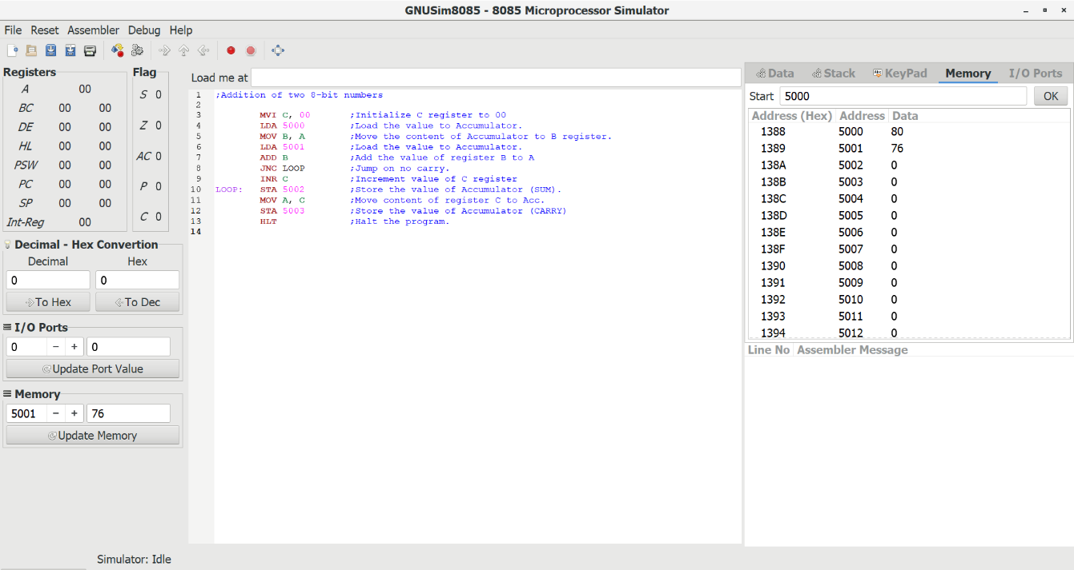
After Execution:
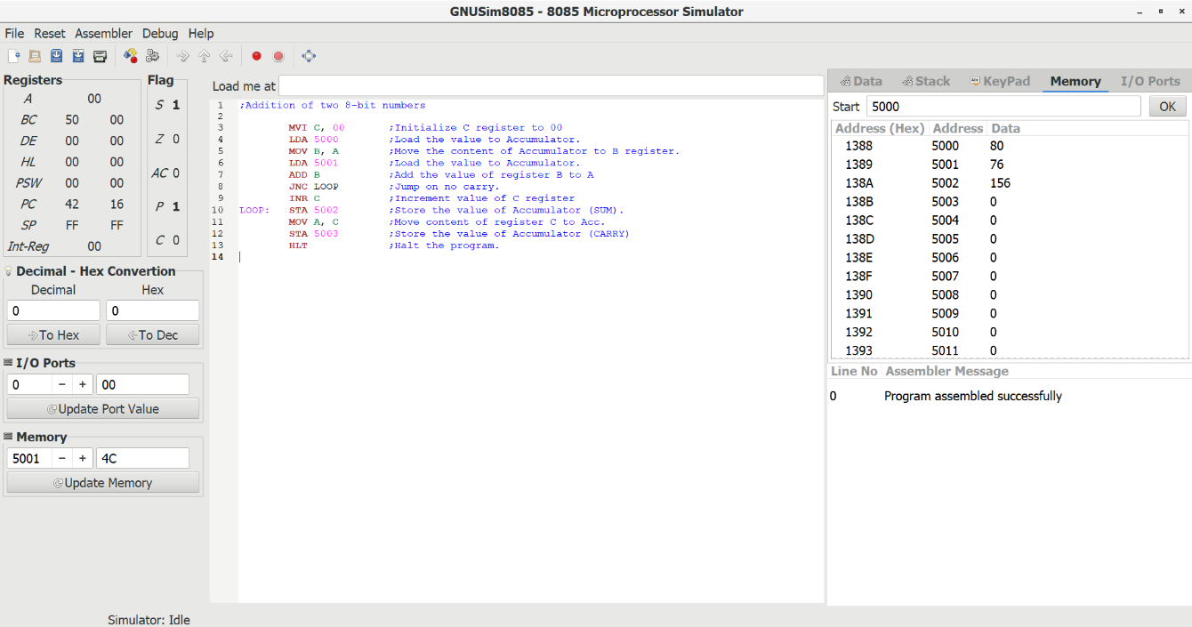

Practical-4B
Aim:- Write an assembly language code in GNUSim8085 for subtraction of two 8-bit numbers.
Software requirements:- GNU Sim 8085
Method/Algorithm/Flowchart:-
Algorithm:-
1. Start the program by loading the first data into Accumulator.
2. Move the data to a register (B register).
3. Get the second data and load into Accumulator.
4. Subtract the two register contents.
5. Check for carry.
6. If carry is present take 2's complement of Accumulator.
7. Store the value of borrow in memory location.
8. Store the difference value present in Accumulator to a memory location and terminate the program.

Program:-
;Subtraction of two 8-bit numbers

MVI C, 00 ;Initialize C to 00
LDA 5000 ;Load the value to Accumulator.
MOV B, A ;Move the content of Accumulator to B register.
LDA 5001 ;Load the value to Accumulator.
SUB B ;Subtract content of B register from Accumulator.
JNC LOOP ;Jump on no carry.
CMA ;Complement Accumulator contents.
INR A ;Increment value in Accumulator.
INR C ;Increment value in register C
LOOP: STA 5002 ;Store the value of A-reg to memory address.
MOV A, C ;Move contents of register C to Accumulator.
STA 5003 ;Store the value of Accumulator memory address.
HLT ;Terminate the program.

Input:
Data 1: 06 in memory address - 5000
Data 2: 02 in memory address – 5001

Output :-
Data 1: 04 in memory address - 5002
Data 2: 01 in memory address - 5003
Before Execution:
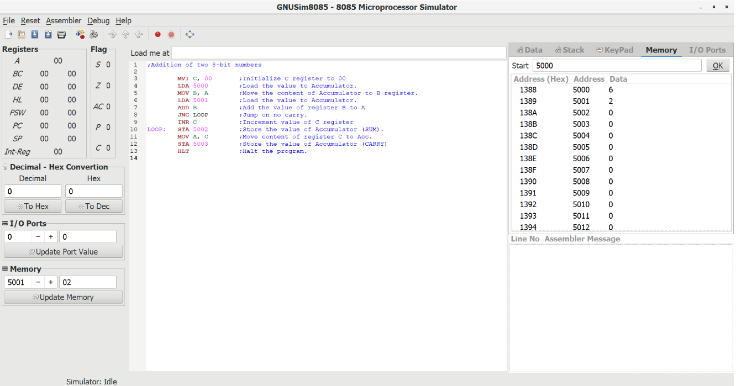
After Execution:

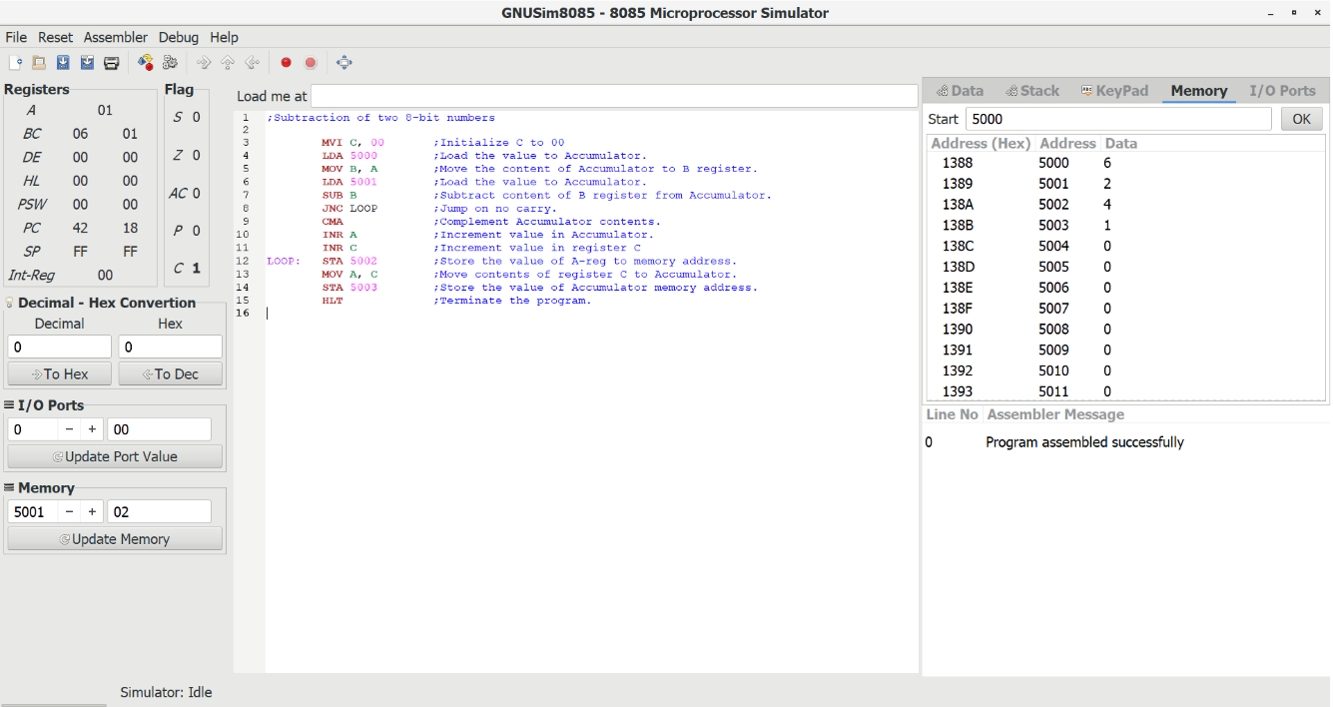

Practical-5A
Aim:- Write an assembly language code in GNUSim8085 for swapping of two 8-bit numbers.
Software requirements:- GNU Sim 8085
Method/Algorithm/Flowchart:-
Assumption :– Suppose there are two 8-bit numbers. One 8-bit number is stored at location 5000 memory address and another is stored at location 5001 memory address. Let 05 is stored at location 5000 and 06 is stored at location 5001 (not necessarily, can be any two 8-bit numbers).
Algorithm :-
- Load accumulator with the content of any one location (either 5000 or 5001 or any given location).
- Move the contents of accumulator to any register (say B) so that another location’s content can be loaded to accumulator and the previous data of accumulator get saved in register.
- Store the content of accumulator to another location (data of 5001 to 5000).
- Load accumulator with content of register and then store it to another address location.
- Terminate the program.

Program :-
;Swapping of two 8-bit numbers

LDA 5000 ; Load accumulator with content of location 5000
MOV B,A ; Copy content of accumulator to register B
LDA 5001 ; Load accumulator with content of location 5001
STA 5000 ; Store content of accumulator to location 5000
MOV A,B ; Copy content of register B to accumulator
STA 5001 ; Store content of accumulator to location 2501
HLT ;Terminates the program

Input :-
Data 1: 5 in memory location 5000
Data 2: 6 in memory location 5001

Output :-
Data 1: 6 in memory location 5000
Data 2: 5 in memory location 5001

Before Execution:
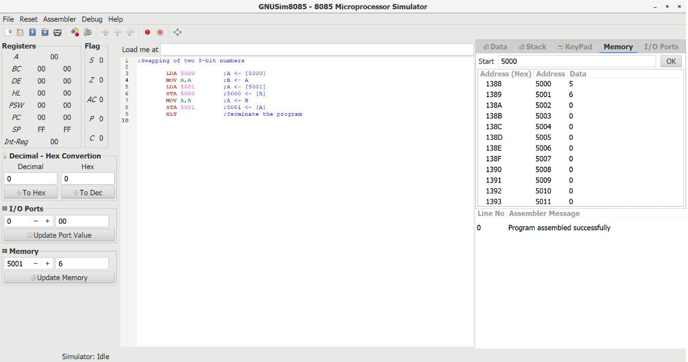
After Execution:

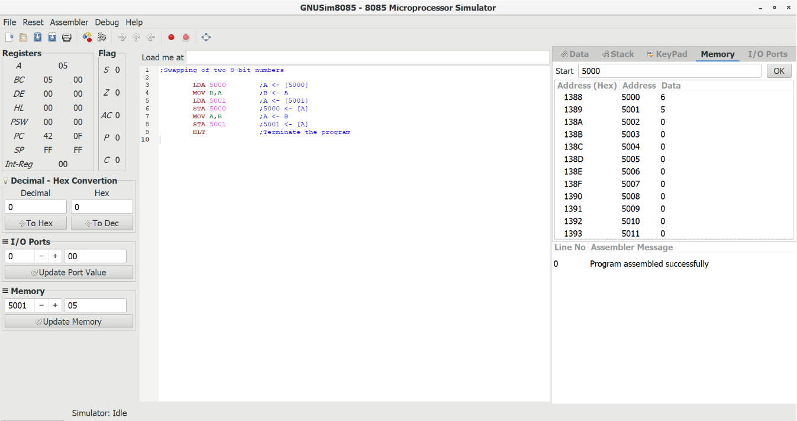

Practical-5B
Aim:- Write an assembly language code in GNUSim8085 for swapping of two 8-bit numbers using direct addressing mode.
Software requirements :- GNU Sim 8085
Method/Algorithm/Flowchart :-
Assumption :– Suppose there are two 8-bit numbers. The first 8-bit number is stored at 5000 memory address and the second 8-bit number is stored at 5001 memory address. Let 05 is stored at location 5000 and 06 is stored at location 5001.
Algorithm :-
- Load a 8-bit number from memory 5000 into accumulator
- Move value of accumulator into register H
- Load a 8-bit number from memory 5001 into accumulator
- Move value of accumulator into register D
- Exchange both the register pairs.
- Terminate the program.

Program :-
Swapping of two 8-bit numbers using direct addressing mode

LDA 5000 ;Load accumulator with content of location 5000
MOV H,A ;Copy content of accumulator to register H
LDA 5001 ;Load accumulator with content of location 5001
MOV D,A ;Copy content of accumulator to register D
XCHG ;exchange the data of both the register pair (H-L), (D-E)
HLT ;Terminate the program

Input :-
Data 1: 5 in memory location 5000
Data 2: 6 in memory location 5001

Output :-
Before Execution:
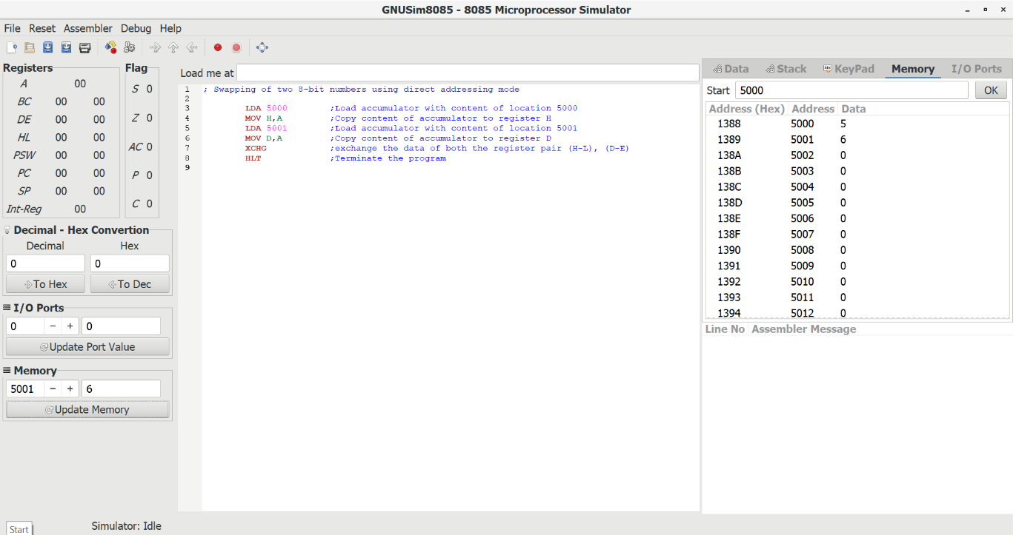
After Execution:
